REPORT TO THE LEGISLATURE

Feasibility Study of Policy Options to Finance
Long-Term Services and Supports

ESSB 6052, Section 206(14)(a)
January 2017

Aging and Long-Term Services Administration
Office of the Assistant Secretary
PO Box 45600
Olympia, WA 98504-5600
(360) 725-2300
https://www.dshs.wa.gov/altsa

TABLE OF CONTENTS

Background…………………………..…………………………………………………………………..3

Description of LTSS…………………….……………………………………………………………....3

Providers and Funders of LTSS..………………………………………………………………….….4

Funding of LTSS…………………………………………………………………………………………5

Demand for LTSS and Impacts on Medicaid Budget Findings……………..……………..........6

Findings……………………………………………………………………………………………………7

Recommendation………………………………………………………………………………………...8

Milliman Study…………………………………………………………………………………………….9

Background

Engrossed Substitute Senate bill 6052 passed in the 2015 legislative session directed the Department of Social and Health Services’ Aging and Long Term Support Administration to contract with an actuarial firm to conduct an independent feasibility study and actuarial modeling of public and private options for leveraging private resources to help individuals prepare for long-term services and supports needs. Milliman, a national actuarial firm was selected through a competitive bid process to conduct the study and they partnered with other firms to conduct the research and analysis. Two options were required to be modeled in the analysis: 1) a public long-term care benefit for workers, funded through a payroll deduction that would provide a time-limited long-term care insurance benefit; and 2) a public-private reinsurance or risk-sharing model, with the purpose of providing a stable and ongoing source of reimbursement to insurers for a portion of their catastrophic long term services and supports losses in order to provide additional insurance capacity for the state.

The study was funded by the state of Washington through legislative appropriation and by interested stakeholders including: American Association of Retired Persons (AARP), Service Employees International Union, Washington Health Care Association, LeadingAge, and the Adult Family Home Council.

The model designs used in the analysis and the topics covered in the report included input from the Joint Legislative Executive Committee on Aging and Disability, as well as a broad group of interested stakeholders. The Milliman report entitled “Feasibility Study of Policy Options to Finance Long-Term Services and Supports in the State of Washington” is attached to this report.

The purpose of this introductory section is to provide overall context and information in understanding the importance, timing and potential impacts of the policy discussions occurring as a result of the feasibility and actuarial modeling study.

Description of Long-Term Services and Supports in Washington State

Washington State has a long and demonstrated history of providing an array of long-term services and supports (LTSS) that allow individuals to choose among settings and providers that will best meet their needs. This has been accomplished through strong federal and state partnerships to leverage federal funding from the Center for Medicare and Medicaid Services and the Administration on Community Living which funds the Older Americans Act and many of the grants used over the years to test models of care. According to the national LTSS scorecard of states created by the AARP, Washington State has sustained the ranking of second in the nation for its high performance while at the same time ranking 34th in cost.

LTSS encompasses the broad range of paid and unpaid skilled and personal care assistance that people may need – for several weeks, months or years – when they experience difficulty completing daily-living tasks as a result of aging, chronic illness, cognitive functioning or disability. LTSS is typically defined as a range of services and supports for individuals who need assistance with daily living tasks such as bathing, dressing, ambulation, transfers, toileting, medication assistance/administration, personal hygiene, transportation and other health-related tasks. For purposes of this report, habilitation services provided to individuals with developmental and intellectual disabilities is not included in the definition of LTSS. LTSS settings include, but are not limited to, skilled nursing facility care, home health services that address chronic care needs, personal care services, adult day services, personal emergency response systems, meals and transportation. Although individuals of any age may receive these services, the need for LTSS is strongly correlated to advanced age with national estimates predicting that approximately 70% of people over the age of 65 will need some form of LTSS in their lifetime.

Providers of Long-Term Services and Supports

Long-term services and supports are delivered in institutional and home and community-based settings through formal (paid) and informal (unpaid) providers. In Washington, LTSS settings include services provided in a person’s home or in assisted living facilities, adult family homes, skilled nursing facilities, or congregate care retirement communities. These settings provide assistance with personal care services and some are also required or choose to provide assistance with skilled nursing and therapies, activities, rehabilitation and coordination of care.

The average length of stay in Medicaid funded LTSS in Washington State is 43 months.

In addition services such as meals, respite, transportation, assistive devices, durable medical equipment, personal emergency response systems, environmental modifications and training and consultation related to the impacts of chronic conditions are critical and often low-cost interventions that assist individuals to remain safely in their own homes. Some of these services delay or prevent the need for more costly services such as the need for home health or personal care services. Providers of this broad array of LTSS include a range of not-for-profit entities and for-profit businesses in both the medical, social services and high-tech industries.

Over 80% of long term services and supports needs are provided by unpaid family caregivers. Washington has approximately 830,000 unpaid family caregivers supporting loved ones in their homes. The care they provide has an estimated economic value of $10.7 billion annually, almost five times what the state of Washington spends annually on Medicaid funded long-term services and supports.

However, the caregiver support ratio is expected to plummet as boomers transition from caregivers into old age. In a 2013 report by AARP, the caregiver support ratio was more than 7 potential caregivers for every person in the high-risk years of 80-plus in 2010. By 2030, the ratio is projected to decline sharply to 4 to 1; and it is expected to fall to less than 3 to 1 in 2050, when baby boomers will be in the high-risk years of late life.

Funding of Long-term services and supports

Medicaid is the primary public payer of long-term services and supports, funding approximately 60% of the state’s nursing home residents. Medicaid is also the primary public payer of LTSS provided in community based settings such as an individual’s own home, Adult Family Homes and Assisted Living Facilities. To qualify for Medicaid, individuals must meet
low-income requirements and have few to no assets. Therefore, individuals in need of LTSS must pay out of pocket for services until they impoverish themselves to qualify for Medicaid.

Medicare coverage of LTSS for seniors, non-elderly people with disabilities, and people with certain chronic conditions is limited. Under Medicare only medically oriented services are covered. For example, home health services are only covered for beneficiaries who are homebound and the services are generally short-term in nature. Post-acute nursing facility care is covered for up to 100 days following a qualified hospital stay. Personal care and other non-medical services are not covered by Medicare.

Individuals and families also use their own private resources and incomes to pay for needed services. Many Washington citizens are not prepared for the cost of LTSS. One in five older adults in Washington State rely on social security as their only source of income. The need for home and community-based long term care can double or even triple the expenses of an elder.

According to a Genworth Cost of Care Survey from June 2015. Adding a low level of care for one person to receive care in their own home adds $11,669 per year to living costs (estimated at 8 hours a week). Requiring a medium level of care adds $29,172 (20 hours a week); and needing a high level of care adds $58,624 (40 hours a week). Costs for a semi-private room in a nursing home range from $90,000-$100,000. These costs are examples based upon private pay rates in urban areas of the state. Actual LTSS costs vary by geographic location, provider type, and by fund source (for example private pay compared to funds through public programs such as Medicaid).

Due to costs of LTSS, it is common for individuals to quickly spend down assets and then become eligible for Medicaid funded LTSS. Approximately 11% of the individuals who apply for Medicaid funded LTSS in Washington must first spend down their assets to qualify for needed services. In addition, individuals who own a home and receive Medicaid funded LTSS are subject to estate recovery upon their death which allows the state to recover expenses for the services that were paid out by the state. Estate recoveries average $13.7 million per year.

Private long-term care insurance is also a source of funding LTSS. However, only 50 individuals per 1,000 age 40 or older in Washington have private long-term care insurance policies. This low penetration rate is due to a number of factors including affordability, reductions in the number of carriers, volatility in that segment of the insurance market and a lack of predictability for consumers in premium and benefit levels. Additional information regarding private long-term care insurance and the private/public reinsurance or risk-sharing model can be found in the Milliman study.

Demand for LTSS and Impacts on Medicaid budget
Projected growth of older population in WA State as percentage of 2012 population
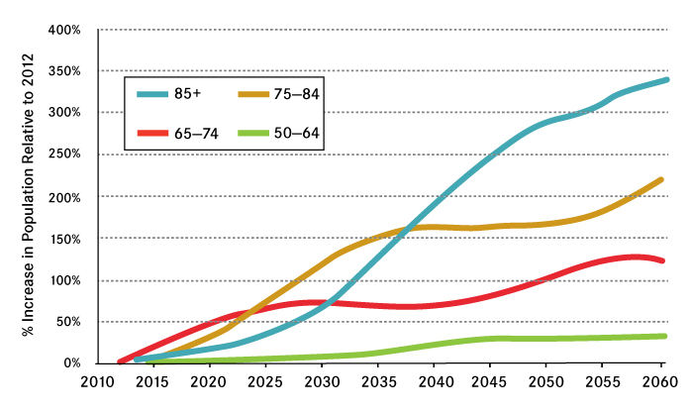
Currently, more than 77,000 people in Washington State rely on Medicaid funded long-term services and supports each year at an annual cost of $2.1 billion. The growth of the Medicaid LTSS served population is forecast to increase by 91% by 2040, with the highest increase for people who will be age 85 and older.

Over the past 20 years, the population of individuals ages 65 and older also doubled. Washington successfully managed this population growth and its increased demands for long term services and supports by rebalancing the system from a reliance on costly institutional care to creation of a community based system that is more cost effective and preferred by individuals in need of assistance.

Expanding home and community-based services results in greater consumer satisfaction, supports families to stay together and also achieved an estimated cumulative savings in tax payer dollars of $2.7 billion over the state fiscal year period of 2000-2014. Assisting individuals to receive services in community based settings remains a priority for DSHS. A commitment to continued innovation to ensure services are high quality, continue to meet changing needs and preferences of the individuals served and are delivered in cost effective ways is at the core of DSHS’s approach to delivery of LTSS.

Developing and expanding services to support unpaid family caregivers also remains a high priority strategy aimed at improving the health and well-being of the caregiver, ensuring individuals in need of LTSS have another option that assists them to remain in their own homes and delay or divert from more costly LTSS services. The state’s five-year 1115 Medicaid transformation demonstration waiver will allow the state to test and expand access to these valuable services while also evaluating whether they result in overall avoidance or cost savings to state and federal budgets.
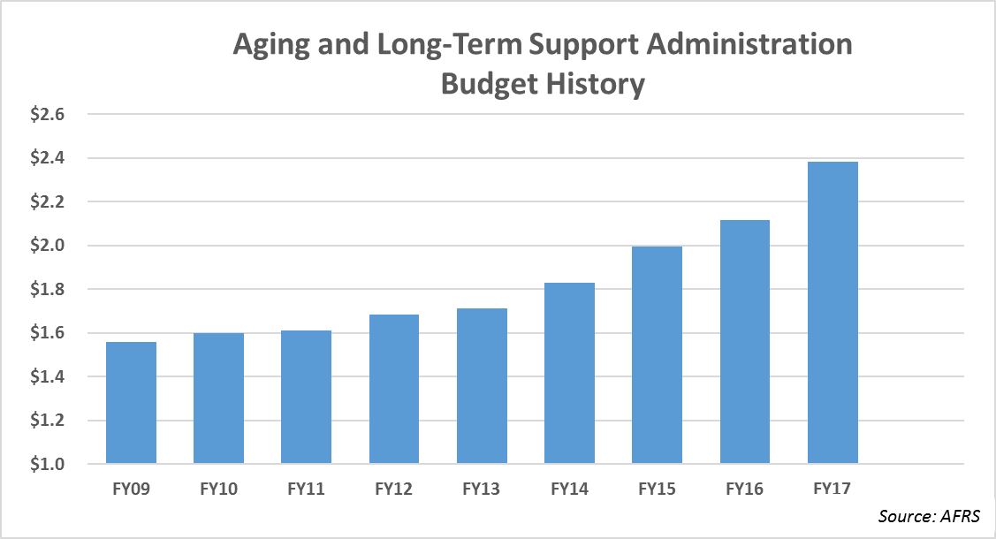
These strategies have proven successful as an approach to delivering services cost-effectively and saving tax payer dollars. However relying on rebalancing and support of family caregivers as primary strategies of sustaining sufficient funding for LTSS will not save enough money to fund the projected increases in caseload that will result from the demographic population shifts in the state.

Current Medicaid LTSS spending represents 6% of Washington State’s operating budget (5% General Fund State) with annual service expenditures of $2.1 billion. The ALTSA budget is increasing an average of 12% a biennium as the number of individuals qualifying for Medicaid funded LTSS grows consistent with the demographic age wave. Over half of that increase is due to caseload growth with the remainder due to increases in service costs.

The rising growth in projected public expenditures for LTSS is not unique to Washington State, it is also experienced at the federal level as well as internationally as LTSS expenditures as a percentage of Gross Domestic Product is projected to almost triple (RTI International presentation to JLEC on Aging and Disability, 2014).

Findings

- The number of individuals in Washington who need LTSS is growing proportional to the increase in the number of individuals ages 65 and older.
- Medicaid expenditures for LTSS continue to rise and have become a larger proportion of spending at both the national and state level. A majority of this expenditure increase is due to caseload growth.
- Based on design input from Washington stakeholders, the Milliman report found a public LTSS insurance benefit for employees funded through a mandatory payroll deduction has the potential to generate savings to the Medicaid program if it is designed as the first payer of LTSS. The amount of savings is impacted by benefit design alternatives such lifetime maximum benefits, daily benefit amount, etc.
- Based on design input from WA stakeholders, the Milliman report found the public-private reinsurance program has little potential to generate savings to the Medicaid program based upon reimbursement approaches to insurers using the products currently available in the market. However, the Milliman report does discuss a potential approach to a reinsurance program that could be further investigated. However, it would require a significant shift in the current product design available in the private market and further investigation would be required to determine feasibility.
- The payroll surtax rate needed to fund a public insurance benefit depends upon the benefit design variables chosen as part of the plan. These are determinations that can and should be made by policy makers. Some variables are much more sensitive than others in terms of impacting the rate of surtax needed to support them.
- Both the public insurance benefit for employees and the public-private option required critical assumptions be made to model costs and utilization spanning over seven decades. There is inherent financial risk to any program that is intended to span decades.
- There are potential legal considerations in the design and development of either option modeled in the Milliman report.
- The types of services and supports available to meet the needs of daily living tasks have changed dramatically over the last 30 years and are anticipated to continue to evolve and develop. It is important to ensure there is flexibility in how eligible enrollees could choose to spend their benefits (up to the lifetime maximum) and the types of providers or services that are considered eligible provider/services under the benefit design.
- Individuals and families are in the best position to determine what services and supports they need in order to maintain a maximum level of independence. Benefit design and administration should be done in a manner that recognizes and supports self-direction, autonomy and choice.
- 35% of Medicaid LTSS clients receive services for 12 months or less; 49% 24 months or less; 59% 36 months or less; 68% 48 months or less; 83% 60 months or less; with the remaining over 60 months.

Recommendation

Understanding the problems policy makers want to solve and the policy goals the state desires to achieve is important in designing the policies, strategies and funding mechanisms that have the highest opportunity to achieve those goals.

The strategies and benefit designs employed will have impacts on the viability of those benefits, costs to individuals as well as the extent to which the benefits will assist individuals with LTSS needs delay or avoid impoverishing themselves to qualify for Medicaid. Those policy choices will also inform how a public LTSS insurance benefit for workers impacts individual, state and federal budgets.

The fact that there will be a significant increase in the number of individuals who will need LTSS is undeniable. Most citizens are not prepared for the financial burden of paying for needed services and only 7% of Washingtonians have insurance for their long term care needs. Exploring strategies that will help individuals contribute toward the cost of needed LTSS while creating sustainable mechanisms to fund a portion of LTSS costs will:

- Ensure individuals have access to some level of LTSS without impoverishing themselves to receive services through Medicaid
- Reduce the likelihood of needing to utilize waitlists or consider reductions in Medicaid benefits as a way of addressing budget pressures
- Help individuals and families pay for needed LTSS

